**Eufevio Jimenez Barrica**

***Purok 7, Poblacion***

***Manticao, Misamis Oriental***

***Contact #: 09263888760/ 09451249719***

***E-mail Address:*** [***ej_barixs@yahoo.com***](mailto:ej_barixs@yahoo.com) **/** [***barixs61392@gmail.com***](mailto:barixs61392@gmail.com)

***Linkedin Account: https://www.linkedin.com/in/eufevio-barrica-62733685/***

**OBJECTIVES:**

I am looking for a job and opportunity where I could practice my knowledge and skills to develop my personality. Willing to learn and listen and opted to work with less supervisions, honest.

**PERSONAL INFORMATION:**

Nickname : Fev/ Barixs

Gender : Male

Age : 28

Date of Birth : June 13, 1992

Place of Birth : Dr. Uy Hospital Iligan City, Lanao del Norte

Civil Status : Single

Citizenship : Filipino

Height : 170cm

Weight : 216lb

Religion : Roman Catholic

Dialects : Filipino, English, Cebuano & Surigaonon

Mother’s Name : Marilou J. Barrica

Occupation : Deceased

Father’s Name : Amadeo Ignacio K. Barrica

Occupation : None

**EDUCATIONAL BACKGROUND:**

Tertiary Education:

**St. Peter’s College**

Sabayle St. Iligan City

**Bachelor of Science in Civil Engineering (2017- Present)**

**St. Thomas of Villanova Institute in San Augustine Center of Studies**

Brgy. VASRA, Visayas Avenue, Diliman, Quezon City

**Bachelor of Art in Philosophy (2012-2013)**

**Mindanao State University Naawan**

Naawan, Misamis Oriental

**Bachelor of Science in Hotel and Restaurant Management (2011-2012)**

Secondary Education:

**St. Anthony Parish School**

Manticao, Misamis Oriental

2007-2011

Primary Education:

**Northeast II-A Central School**

Dalipuga, Iligan City

2000-2006

**WORK EXPERIENCE:**

**Generika Drugstore - Senior Pharmacy Assistant (2014 -2020)**

Naawan, Misamis Oriental

* Prepared packaging and labels for prescriptions, verifying accuracy of dosage, side effects, interactions and refill instructions.
* Assisted pharmacist by filling prescriptions for Number customers daily and responding to patient questions regarding prescription and medication-specific issues.
* Processed incoming drug orders.
* Locate and measure medications according to prescription information, making modifications as instructed by pharmacists and providers.
* Counted and label prescriptions with correct item and quantity.
* Monitored inventory levels to inform pharmacists of shortages and facilitate resupply.
* Handled inventory stock by counting inventory items, checking delivery quantities, reviewing medication expirations and ordering additional products.
* Completed cash register transactions by handling credit and cash payments using pharmacy register system.
* Boosted sales and delivered outstanding customer service by assisting customers with pharmacy services, product questions and general store information.

**Generika Drugstore - Site Computer Support Technician (2014 -2020)**

Naawan, Misamis Oriental

* Installing and configuring computer hardware, software, systems, networks, printers, and scanners
* Monitoring and maintaining computer systems and networks
* Responding in a timely manner to service issues and requests
* Providing technical support across the company (this may be in person or over the phone)
* Setting up accounts for new users
* Repairing and replacing equipment as necessary
* Testing new technology
* Possibly training junior staff.

**Cagayan-Iligan Transport Service Multi-Purpose Cooperative- Admin Assistant (2013-2014)**

Manticao, Misamis Oriental

* Coordinated travel arrangements, including booking airfare, hotel and ground transportation.
* Organized envelopes, postage and mail correspondence for staff and management, maintaining postage meter and coordinating with delivery and courier services.
* Sorted, opened and routed incoming correspondence and deliveries to help senior leaders respond quickly to business and customer requirements.
* Maintained office supplies inventory by checking stock and ordering new supplies as needed.
* Wrote and proofread error-free letters, memoranda and other business correspondence.

**DIALBOX SOLUTIONS P/L (2020)- Admin Support/ VA/ Appointment Setter**

Brgy. San Antonio, 17 ADB Ortigas Center Pasig City Philippines

* Lead Generation
* Cold Calling
* Appointment Setting for INXPRESS Freight and Logistics
* Admin of Immigration Facebook Page for Australia, doing advertising.
* Making PPT for Operation Plan
* Microsite Admin Support

**CERTIFICATES AND AWARDS:**

* **Certificate of Completion Construction Occupational Safety and Health Training**

April 2014

* **Certificate of Completion Construction Occupational Safety and Health Training**

October 2014

* **Certificate of Award for Welding Course**

May 2017

* **Training Certificate SMAW NC II**

May 2017

* **National Certificate II**

May 2017

* **Certificate of Participation for Pre-Employment Seminar**

May 2017

* **Certificate of Participation for Disaster Preparedness & Risk Reduction Seminar**

October 2017

**OTHERS:**

* **Member of Alpha Sigma Phi 1845**
* **Elected as Representative for Civil Engineering Department from 2017 - present**
* **Finished Course Certificate in COVID-19 Contact Tracing facilitated by John Hopkins University.**

***I hereby certify that the above information’s are true and correct to the best of my knowledge and belief.***

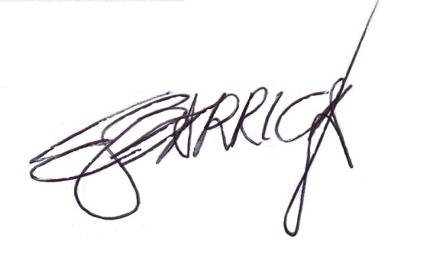

***Eufevio J. Barrica***

Applicant